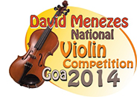
APPLICATION
FORM

Fill the application Form and mail it to dmello.nessa@gmail.com /davidmenezesviolincompetition@gmail.com

Surname:

Name:

Address:

Telephone Number:

E-mail:

Date of Birth:
Sex: M F

DECLARATION

I, state the following:

a) I have read the rules and regulations of the competition.
b) I am eligible to apply as I am an Indian National / a person of Indian origin / a foreigner domiciled in India for more than five years. (strike out the option whichever is not applicable.)
c) I agree to abide by these rules and regulations.

Signature

Date

Place ______

